EVAL-AD5791 control with an Arduino
The EVAL-AD5791 [1] board can provide very low noise voltage output. The 20-bit DAC in a default output range of 20 V provide a high resolution of 1LSB≈19 μV. Full characterization is presented later. The board can operate with a single power supply of +3.3V and can be controlled with an SDP-CB1Z controller board[2]. The accompanied software is provide by Analog Devices for free [1]. However, the controller board has an additional cost of about $99 (February 2020 price in Analog Devices website) and the software is not open to the user so it does not allow for any modification or synchronization with other devices. This motivated the initiative to control the DAC in another way and specifically using an Arduino.
The Arduino can load the Serial Peripheral Interface (SPI) library [3] and allow to provide all the necessary firmware and clocking to the DAC board through the J12 connector. Since the DAC does not require high speed, the Arduino was proved capable to support it. Moreover, the Arduino can offer a power supply of +3.3V and simplify the setup to the minimum. So, the full setup requires a PC with the Arduino IDE software, free on the Arduino website available for most operating systems, a USB A - USB B cable, an Arduino or alternative microcontroller platform and the DAC board.
For this particular study an Arduino Mega2560 is used. The connection of the Arduino with the DAC board requires male-female pin cables. The most important signals to the DAC are the SYNC (aka SS: Slave Select or CS: Chip Select), SCLK (Serial Clock), SDIN (aka MOSI: Master Out Slave IN), SDO (aka MISO: Master In Slave Out), where Master is the Arduino and Slave is the DAC board. A digital ground (DGND) is also necessary. The +3.3V can be supplied at the IOV_{CC} pin. For all the above, the Arduino has special pinouts that vary from different models (see Figure X in the appendix). The LDAC, CLR and RESET pins are not used simply because the DAC can operate with these values fixed and this can achieved by modifying the board with jumpers. Basically, bar(LDAC) needs to be Low and the LK3 jumper needs to be inserted, and the rest two need to be High so the jumpers must be removed. The LK1 can stay always at position A, but for safety if the power supply is provided by the Arduino, it can be removed.
The installation instructions of the Arduino IDE software in a Linux operating system, like CentOS 7, based on the webpage https://www.arduino.cc/en/guide/linux:
- Download the Arduino software from the official website.
- Extract the package.
- Open a terminal operating in the folder that will be created in step 2 and run ./install.sh .
An error will occur.
- One need to run the command ls -l /dev/ttyACM*
- and then run sudo usermod -a -G dialout <username> , where <username> is the login user name.
The script that controls the DAC is given in the appendix. This version can provide all the basic functions the original software:
- single DAC input code with desirable DAC output voltage, DAC input must be an integer in the range 0 to 2²⁰-1,
- with the word SCAN: full scan from a start-code to a stop-code with a given step-code and a delay-time in every step, where the parameters can change in the script for the moment,
- with the word RESET: resets the DAC in its initial state.
Further information and instruction can be found in the script. Some brief instruction to use the Arduino code:
- Open the Serial Monitor, top right corner of this window if opened with the Arduino app.
- In the Serial Monitor set "Autoscroll" (optional), "Show timestamp" (optional), "No line ending" ( MANDATORY! ), "57600 baud" ( MANDATORY! ).
- To stop operating, just unplug the Arduino from the PC or power it off.

APPENDIX

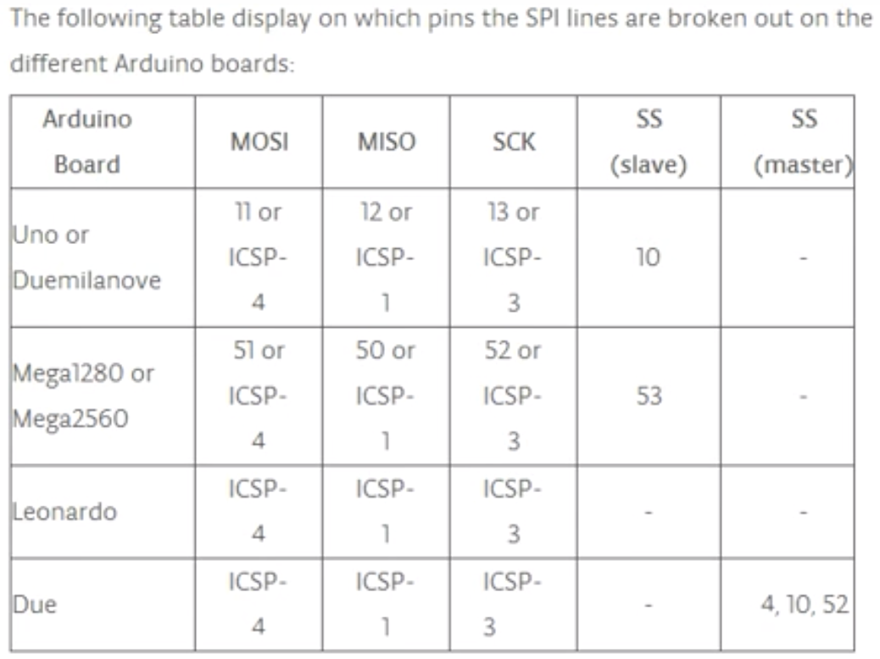
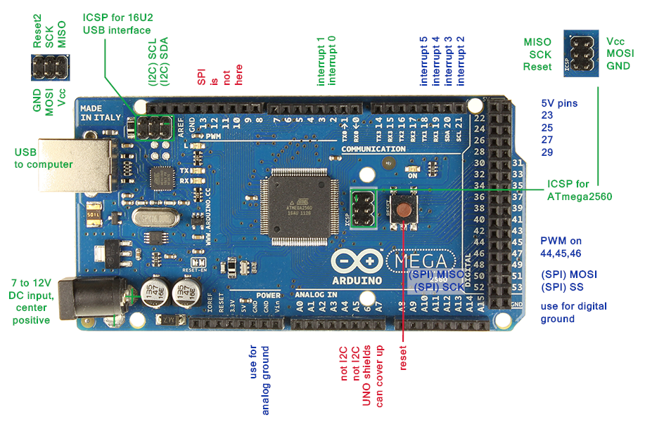
References:
[1]: EVAL-AD5791 evaluation board by Analog Devices
https://www.analog.com/en/design-center/evaluation-hardware-and-software/evaluation-boards-kits/eval-ad5791.html#eb-overview
[2]: SDP-B Controller board by Analog Devices
https://www.analog.com/en/design-center/evaluation-hardware-and-software/evaluation-boards-kits/sdp-b.html#eb-overview
[3]: SPI library by Arduino
https://www.arduino.cc/en/reference/SPI

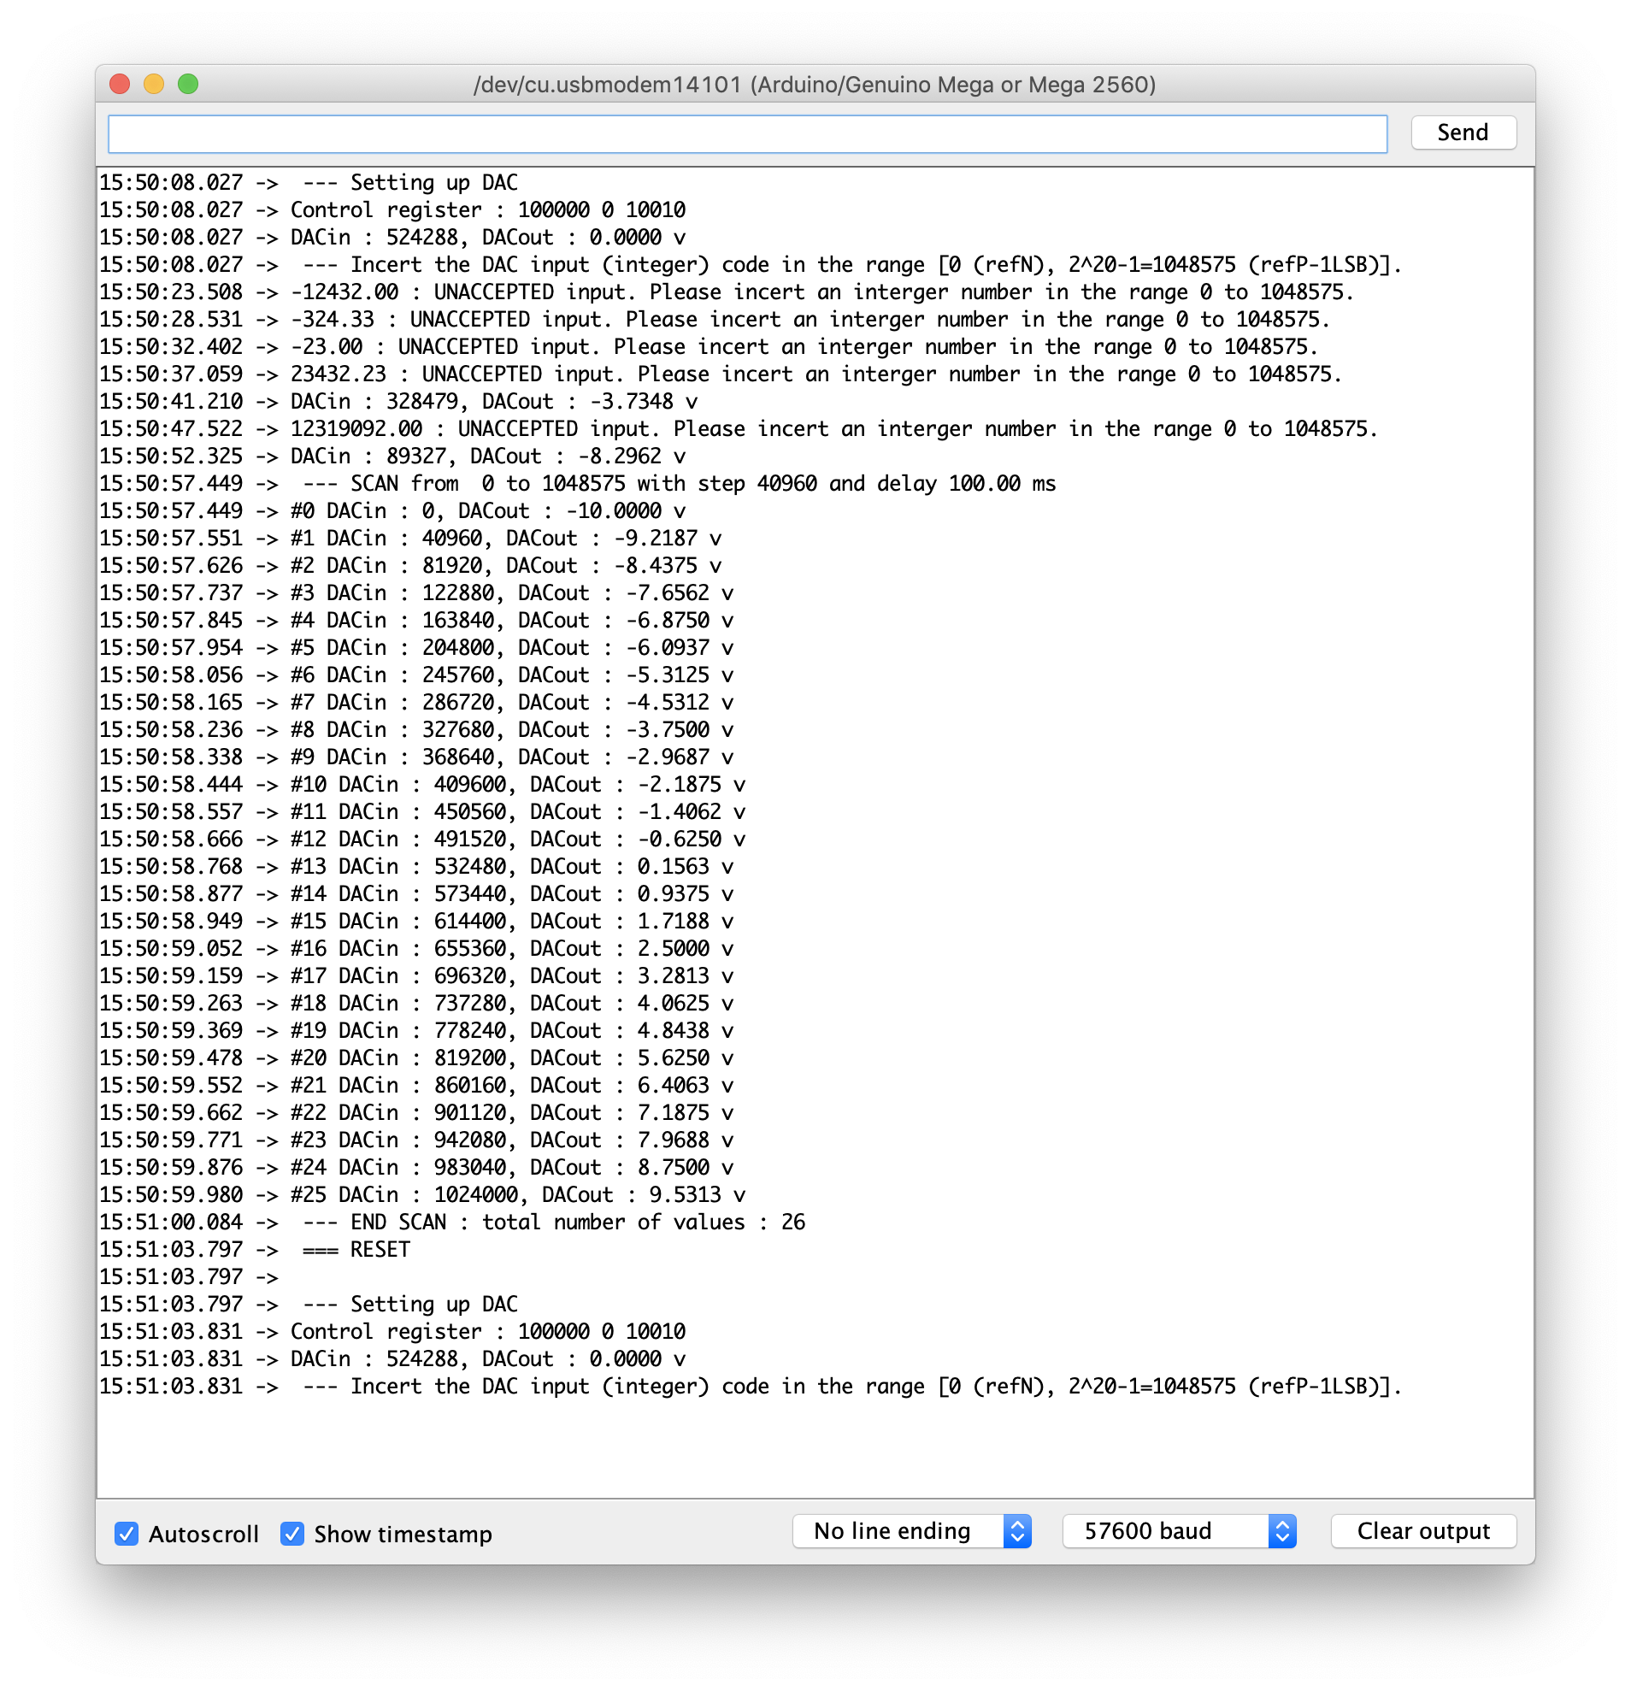
Serial Monitor output example

